# Overview

1. Architecture flexible
2. User friendly
3. Performance and efficiency
4. Security
5. User roles
6. Modular based development

# Wireframes

<https://7g39sv.axshare.com/home_page.html>

# Features

|  |  |  |  |
| --- | --- | --- | --- |
| Hospital management | Health Insurance | HR Management | HIN Administrator |
| Signup reps | Signup reps | View company data | Create Hospitals |
| Login | Login | View employee data | Create Corporate |
| Dashboard | Dashboard  i. Widgets for viewing information and filtering the data  ii. List of new/extension requests  iii. Quick message widget | Apply for addition, updating or deletion of company and/or employee data. | Create Individuals |
| Search Patient Feature | Signup new clients - Individuals | Export employee data as excel | Create Insurance |
| Widgets for viewing information and filtering the data  i - View previous data of client  ii - View the card  iii - Remaining balance and limit | Signup new clients - Corporate | Import employee data as excel | Searching capability |
| List of new Applications | View Patient Data | Send data to Insurance for approval | View patient information |
| View tariff | Approve / disapprove / addition / deletion / modification of individuals created by corporate clients | View employees which are currently in treatment | Manage patient database and view all information in the system |
| Claims | Export functionality with advance filter | Notification System | Manage Tariff |
| Notification System | Export import patient data |  | Billing Dashboard |
| Apply for new/extension episode | Download user card. |  | Add/Edit/View information for Insurance company |
| Discharge | Manage Tariff  i. View Hospital tariff  ii. Modify Hospital tariff |  | Add/Edit/View information for Hospital |
| Past approvals | View claims |  | Notification System |
| Chat | Approve / Reject the new/extension episode |  | Manage Subscription |
|  | Notification System |  | Communicate with each and every role to provide support |
|  |  |  |  |
| Messaging center |  |  |  |
| HIN Admin | HIN Admin | HIN Admin | Hospital |
| Insurance | Hospital | Insurance | Insurance |
|  | HR Management |  | HR Management |

# Feature details

|  |  |  |
| --- | --- | --- |
| Sign Up |  |  |
| Create User | Email address  User Name  Password |  |
| New Roles | Name  Description  Rule - (Hospital | Insurance | HR Companies | Admin)  - Sub Rule (Hospital lists / Insurance lists) |  |
| View users | Show user details  Link roles from drop down  Activate / Deactivate |  |
| Create New Hospital | Name, Description |  |
| Create New Insurance | Name, Description |  |
| View Hospital Details | Name, Description, Fever, Standard Pricing Approvals |  |
| View Insurance Details | Name, Description, Policy Number Range |  |
| Login | Username  Password  Forgot password - send password as email |  |

|  |  |
| --- | --- |
| Hospital management | Single page website - data loading |
| List of Hospitals | Show list of hospitals |
| Dashboard | Search Patient from (Mobile number, CNIC, Policy ID)  Approval Pending lists | Approved Cases | Claim Process  Name | Policy number | CNIC | Diagnosis | Insurer | Date & Time | Status | Action  Date Range  Pagination  Messages |
| **How to claim** |  |
| Search Patient Feature | Using mobile phone number  Using CNIC  Policy ID |
| Claim form | **View Only**  Patient Name | Card Display | CNIC  Sample Card with: Name | Policy number | Valid date | Authorized family names  **Buttons**  Eligible | Extension | Tarriffs | Attachment Image | Submit  **Fields**  **- Cost estimations:** drop down 10k - 50k, 75k, 100k, 150k, 200k  **- Case Type:** In-Patient | Daycare | Out-Patient  **- Length of stay:** 1d - 6d, 1wk, 2wk, 1 month  **- Diagnosis:** list - code - Illness  **- Date of treatment:** Date Picker  **- Additional Information:** Doctor name, details for making case stronger |
| Widgets for viewing information and filtering the data  i - View previous data of client  ii - View the card  iii - Remaining balance and limit |  |
| List of new Applications |  |
| View tariff |  |
| Claims |  |
| Notification System |  |
| Apply for new/extension episode |  |
| Discharge |  |
| Past approvals |  |
| Chat |  |

# User Flows

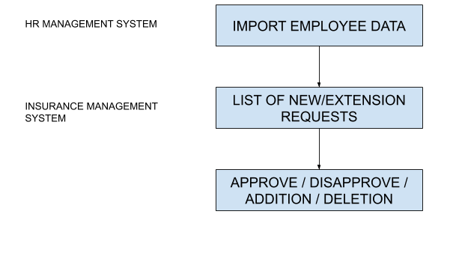

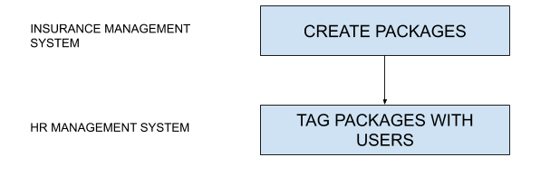

Claim process

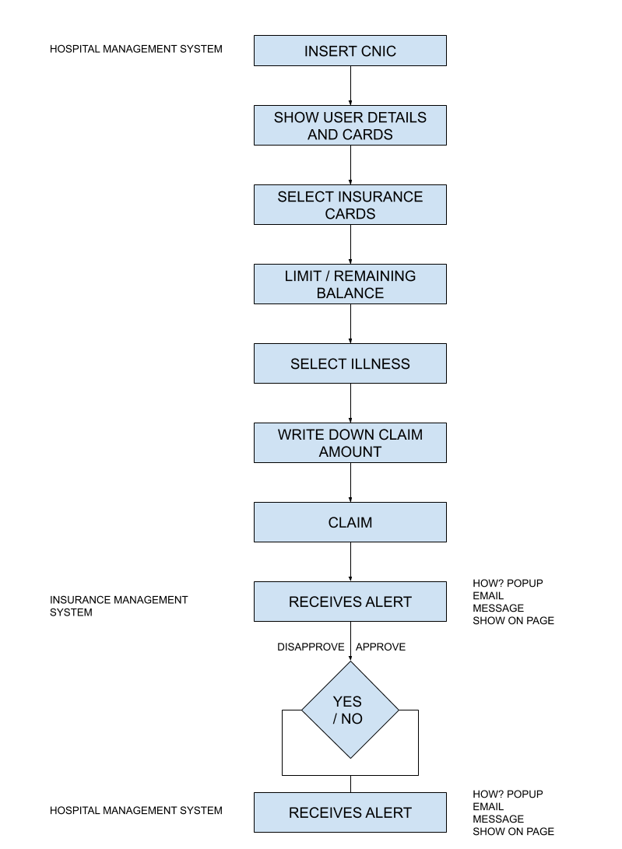

Discharge process

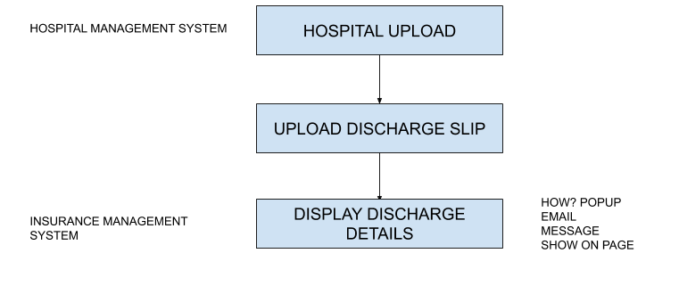

Messaging

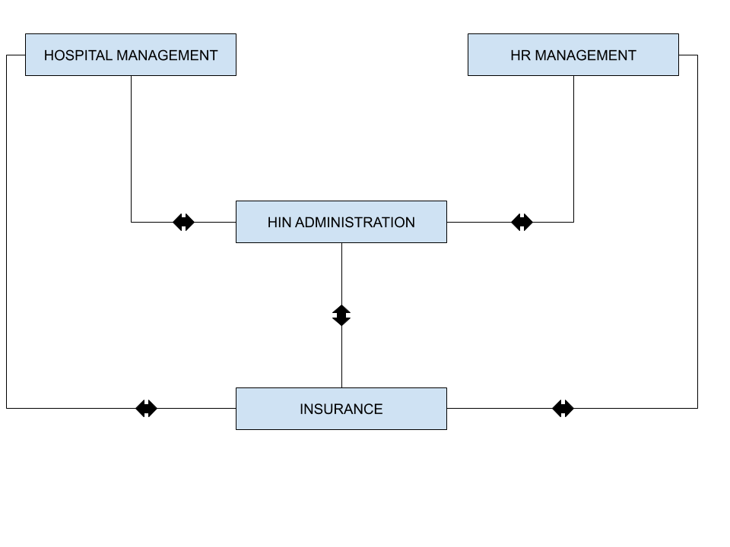

# ER Diagram

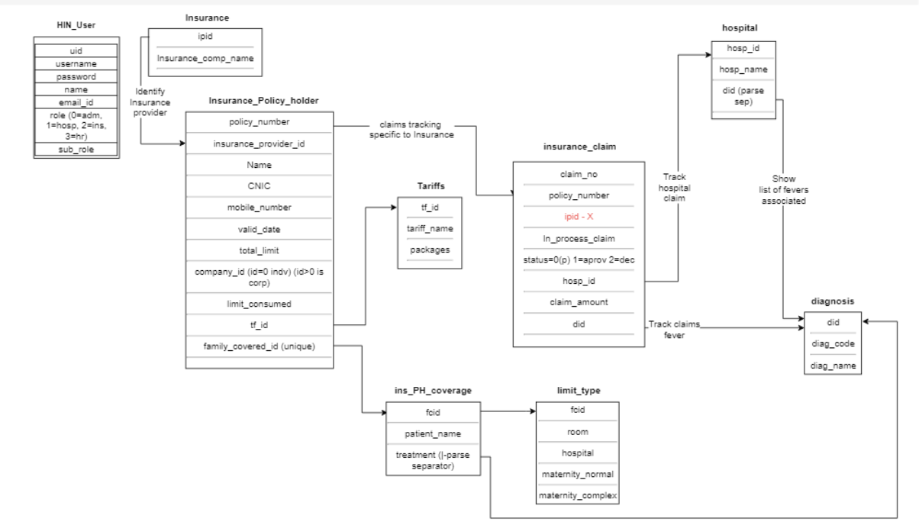

# 

# Use Case

1. As an HIN admin, I can see
   1. Hospitals
   2. Insurance companies
   3. Organizations
   4. HIN admin mode

## HIN Administrator

1. As an admin user, create list of new hospitals
2. As an admin user, create list of new insurance companies
3. As an admin user, create list of new corporate and individuals
4. As an admin user, create new users
5. As an admin user, assign roles to the users so that they can either log into any one of the above options

## Hospital Management

1. Insert username and password to log into hospital portal
2. Based on sub-role id user logs into specific hospital  
   **DASHBOARD**
3. As a hospital user, when logged in, it will show list of all activities on dashboard approval pending / approved declined and their total sums as button
4. As a hospital user, user can click on Approval pending on dashboard to show list of pending approvals below
5. As a hospital user, user can click on Approved cases to show list of all approved cases
6. As a hospital user, user can click on Approval declined to show all declined claims by insurance agent
7. As a hospital user, for all pending payment rows, user can click reminder button to remind insurance agent
8. As a hospital user, above from and to date will show sum of pending, approved, decline widget
9. As a hospital user, below widget from and to date will show range of rows as per dates  
     
   **CLAIM**
10. As a hospital user, type patient as policy holder CNIC number to search patient details by clicking on search patient button
    1. CNIC
    2. Mobile number
    3. Policy number
11. As a hospital user, it will show patients multiple policies if search from CNIC or Mobile number if available
12. As a hospital user, select card to show policy details if corporate or independant
13. As a hospital user, it will show following details
    1. Patient name
    2. CNIC name
    3. Valid till date
14. As a hospital user, following information is editable
    1. Cost Estimation select from dropdown range
    2. Case type
    3. Length of stay
    4. Diagnosis - select codes and illness name
    5. Date of treatment
    6. Description
15. As a hospital user, do not allow to insert Length of stay when clicking on Day care
16. As a hospital user, when clicking on Out-Patient it will show Charges Diagnosis | Consultation | Pharmacy
17. As a hospital user, allow to insert image and click submit in Eligibility it will check if it is exceeding limit it will provide LIMIT EXCEED response
18. As a hospital user, allow to insert image and click submit in Eligibility it will check if it is within the limit it will go back to dashboard and create additional row showing pending
19. As a hospital user, if Extension is clicked it will allow to submit when following information is filled, it will perform same behavior as Eligibility
    1. Extension cost
    2. Length of stay
    3. Description
    4. Add Image (optional)
20. As a hospital user, if tariff is clicked it will show all the charges as per the standard
21. As a hospital user, if discharge is clicked insert
    1. Total bill
    2. Date of discharge
    3. Discharge bill

**DASHBOARD**

1. As a hospital user, you can click on View for Approved and Declined Insurance claim to see a reason in dialog box
2. As a hospital user, you can click on Reminder to resend reminder for Insurance claim

**Caims Tab**

1. ??

**Tariff Tab**

1. As a hospital user, you can click on Tariff to see different packages such as room rent consultation charges Maternity, Diagnosis, Daycare, Pharmacy etc

**Messages Tab**

1. As a hospital user, you can chat with HIN Admin and Insurance companies

**Logout**

1. As a hospital user, you can click logout to go to sign in page from the system

**Insurance System**

# 

# FAQs and Queries

1. Family members?
2. **Limit types:** Normal / Maternity
3. Cost types: Complex / Normal Maternity
4. Secure fraud message to user for claim
   1. If someone else claim is processed
   2. If not expired and claim request after few days
5. If due to pending claims exceeding limit of new request, should we validate?
6. Expiration of reminders